**Assignment 4**

**Experiment 6**

**Objective:**

Write a program to find 2’s complement.

**Statements:**

Input numbers from memory location 2013H and store result in memory location 2052H.

**Steps:**

* Load the contents from 2013h memory location.
* Complement the contents of the accumulator.
* Add 01h to the contents of the accumulator.
* Store the contents in 2052h memory location.

**Programs:**

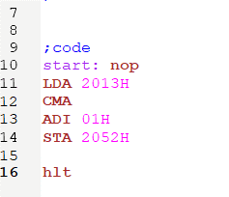

**Inputs and Outputs:**

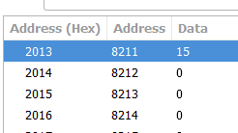

**Registers:**

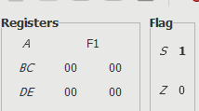

**Experiment 7**

**Objective:**

Write a program to right shift 8-bit numbers.

**Statement:**

Shift an 8-bit data 4-bits right. Assume the data is in memory location 2051h. Store the result in memory location 2055h.

**Steps:**

* Load the contents from the memory location 2051h.
* Rotate 4-bit number 1-bit right 4 times.
* Store the result in memory location 2055h.
* Terminate the program.

**Program:**

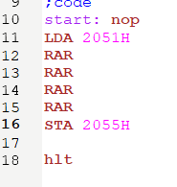

**Input and Outputs:**

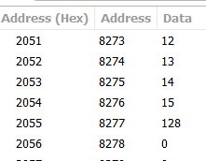

**Registers:**

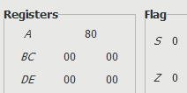

**Experiment 8**

**Objective:**

Write a program to left shift 8-bit numbers.

**Statements:**

Shift an 8-bit data 4-bits left. Assume the data is in memory location 2051h. Store the result in memory location 2055h.

**Steps:**

* Same as experiment 7 (in this case the data is rotated left instead of right).

**Programs:**

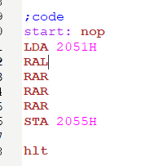

**Inputs and Outputs:**

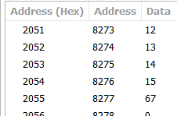

**Registers:**

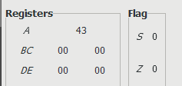

**Experiment 9**

**Objective:**

Write a program to add 16-bit numbers.

**Statements:**

Add numbers 1124H and 2253H and store in memory location 2055h and 2056h.

**Steps:**

* Load 1124h data from HL pair register.
* Load 2253h data from DE pair register.
* Move the contents from l register to accumulator.
* Add the contents from accumulator to E register.
* Move the contents from accumulator to L register.
* Move the contents from H register to accumulator.
* Add the content of accumulator and D register with carry.
* Move contents of accumulator to H register.
* Store the contents in 2055h and 2056h memory location.
* Terminate the program.

**Programs:**

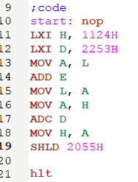

**Input and Outputs:**

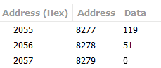

**Registers:**

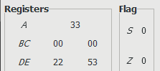

**Experiment 10**

**Objective:**

Write a program to add 16-bit numbers.

**Statements:**

Input first number from the memory location 2050h and 2051h and second number from 2052h and 2053h and store the result in memory location 2055h and 2056h.

**Steps:**

* Load data from memory location in HL pair.
* Exchange content from HL to DE pair.
* Load data from memory location HL pair.
* Move the contents from L register to accumulator.
* Add contents from accumulator and E register.
* Move contents from accumulator to L register.
* Move contents from H register to accumulator.
* Add contents from accumulator and D register with carry.
* Move the contents from accumulator to H register.
* Store the contents in memory location 2055h.
* Terminate the program.

**Program:**

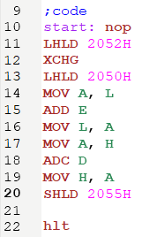

**Input and Outputs:**

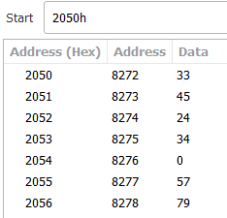

**Registers:**

